Notifications Microservice High-Level Architecture Document (HLAD)
Table of Contents
High-Level Architecture Document (HLAD)
Table of Contents
1. Executive Summary
2. System Context & Software Stack
Software Stack Overview
3. Component Architecture
3.1 Ingestion Layer (Apache Kafka)
3.2 Logic Worker (Node.js - NestJS)
3.3 Provider Gateway (Go)
3.4 Real-Time Gateway (Centrifugo)
4. Data Flow Architecture (The Journey)
Step 1 – Event Trigger
Step 2 – Event Consumption
Step 3 – Preference Validation
Step 4 – Content Rendering
Step 5 – Dispatch Decision
Step 6 – Persistence
5. Non-Functional Requirements
5.1 Scalability
5.2 Reliability
5.3 Observability
5.4 Security
6. Infrastructure Diagram (PlantUML)

1. Executive Summary
The Notification Microservice is an event-driven system designed to decouple business logic (Orders, Users, Payments) from communication delivery. It ensures high availability, multi-channel support (Email, SMS, In-App), and resilient delivery through a distributed polyglot architecture.
This document serves as the authoritative reference for system design decisions, architectural boundaries, and technology selections.

2. System Context & Software Stack
The system is divided into two major domains:
- Logic Layer – Business rules and orchestration
- Infrastructure Layer – Transmission, persistence, and real-time state

Software Stack Overview
Layer | Component | Software Stack
Ingestion | Message Broker | Apache Kafka
Orchestration | Logic Worker | Node.js (NestJS)
Content | Template Engine | MJML + Handlebars
Real-Time | WebSocket Engine | Centrifugo + Redis
Transmission | Provider Gateway | Go (Golang)
Storage | Database | PostgreSQL

3. Component Architecture

3.1 Ingestion Layer (Apache Kafka)
Role: Entry point for all system events.
Topics:
- order.events
- user.events
- marketing.alerts
Purpose:
- Durable buffering of events
- Decoupling producers from consumers
- Traffic spike absorption
- Replay capability for failure recovery

3.2 Logic Worker (Node.js - NestJS)
Role: Core orchestration engine (“Brain”).
Responsibilities:
- Consume Kafka messages
- Validate message schema
- Query PostgreSQL for user notification preferences
- Select appropriate MJML template
- Inject variables using Handlebars
- Dispatch notifications via gRPC
Communication:
- gRPC → Provider Gateway (low latency, structured contracts)
- Direct integration → Centrifugo (internal real-time push)

3.3 Provider Gateway (Go)
Role: High-performance delivery engine (“Muscle”).
Responsibilities:
- High-concurrency network I/O
- Vendor abstraction layer
- Failover routing (e.g., fallback from SendGrid to AWS SES)
- Rate limiting per vendor API policy
- Delivery status handling
Patterns Implemented:
- Circuit Breaker
- Retry with Exponential Backoff
- Provider Failover
- Idempotent request handling
External Providers (Examples):
- SendGrid (Email)
- Twilio (SMS)
- Firebase (Push Notifications)

3.4 Real-Time Gateway (Centrifugo)
Role: WebSocket session manager for in-app notifications.
Responsibilities:
- Maintain persistent WebSocket connections
- Authenticate sessions
- Publish in-app notifications
State Management:
- Redis used as distributed pub-sub backplane
- Enables horizontal scaling across multiple instances

4. Data Flow Architecture (The Journey)

Step 1 – Event Trigger
A business microservice (e.g., Order Service) publishes a “Fat Event” to Apache Kafka.

Step 2 – Event Consumption
The Node.js Logic Worker consumes the event and validates the schema.

Step 3 – Preference Validation
The Worker queries PostgreSQL to determine:
- User opt-in/opt-out status
- Channel restrictions
- Marketing consent

Step 4 – Content Rendering
- Handlebars injects dynamic variables
- MJML compiles responsive HTML
- Channel-specific payload generated (Email HTML, SMS text, etc.)

Step 5 – Dispatch Decision
Internal Dispatch (In-App):
- Worker checks Redis for active session
- Publishes event to Centrifugo
External Dispatch (Email/SMS):
- Worker sends payload to Go Gateway via gRPC
- Gateway forwards to appropriate provider

Step 6 – Persistence
Final notification status recorded in PostgreSQL:
- Sent
- Delivered
- Failed
- Retried

5. Non-Functional Requirements

5.1 Scalability
- All services are stateless
- Horizontally scalable via Kubernetes HPA
- Independent scaling of:
  - Kafka consumers
  - Node.js Workers
  - Go Gateways
  - Centrifugo instances

5.2 Reliability
- Dead Letter Queue (DLQ) implemented in Kafka
- Messages failing 3 delivery attempts moved to a DLQ topic
- Supports replay and manual investigation
- Provider failover logic implemented

5.3 Observability
- OpenTelemetry tracing
- Correlation ID propagation
- End-to-end trace from:
  - Kafka event
  - Worker processing
  - Provider call
  - Delivery callback
Metrics captured:
- Throughput
- Failure rates
- Retry counts
- Latency per provider

5.4 Security
- Encrypted transport (TLS)
- Role-based service access
- Secure secret management
- Payload validation

6. Infrastructure Diagram (PlantUML)
The following PlantUML diagram represents the high-level infrastructure architecture:
@startuml
skinparam componentStyle rectangle
skinparam PackageBackgroundColor #F8F9FA

actor "End User" as User #SkyBlue

package "External Business Services" #White {
[Order Service] as OS
[Identity Service] as IS
}

queue "Apache Kafka" as Kafka #Gold

node "Notification Microservice Cluster" #GhostWhite {

package "Logic & Content Layer" {
[Node.js Worker] as Worker
[MJML/Handlebars Engine] as Render
database "PostgreSQL (Prefs & Templates)" as DB
}

package "Delivery Infrastructure" {
[Go Provider Gateway] as Gateway
[Centrifugo (WebSockets)] as RT
database "Redis (State & Rate Limits)" as RDS
}
}

package "External Providers (The Last Mile)" #White {
cloud "Email (SMTP/API)" {
[SendGrid / AWS SES] as EmailProv
}
cloud "SMS/WhatsApp (REST)" {
[Twilio / MessageBird] as SMSProv
}
}

' --- Interactions ---

OS --> Kafka : 1. Event (OrderCreated)
Kafka --> Worker : 2. Pull Event

Worker --> DB : 3. Fetch User Prefs & MJML Template
DB --> Worker : 4. Return Data
Worker --> Render : 5. Render HTML/Text
Render --> Worker : 6. Compiled Message

' --- Internal Branch (In-App) ---
Worker --> RT : 7a. Internal Push
RT --> RDS : Check Session
RT --> User : 8a. WebSocket Toast (Live App)

' --- External Branch (Out-of-Band) ---
Worker --> Gateway : 7b. gRPC Dispatch
Gateway --> RDS : Check Rate Limits
Gateway --> EmailProv : 8b. HTTPS Request
Gateway --> SMSProv : 8c. HTTPS Request

' --- Final Delivery ---
EmailProv --> User : 9a. Inbox Email
SMSProv --> User : 9b. SMS/WhatsApp Message
@enduml

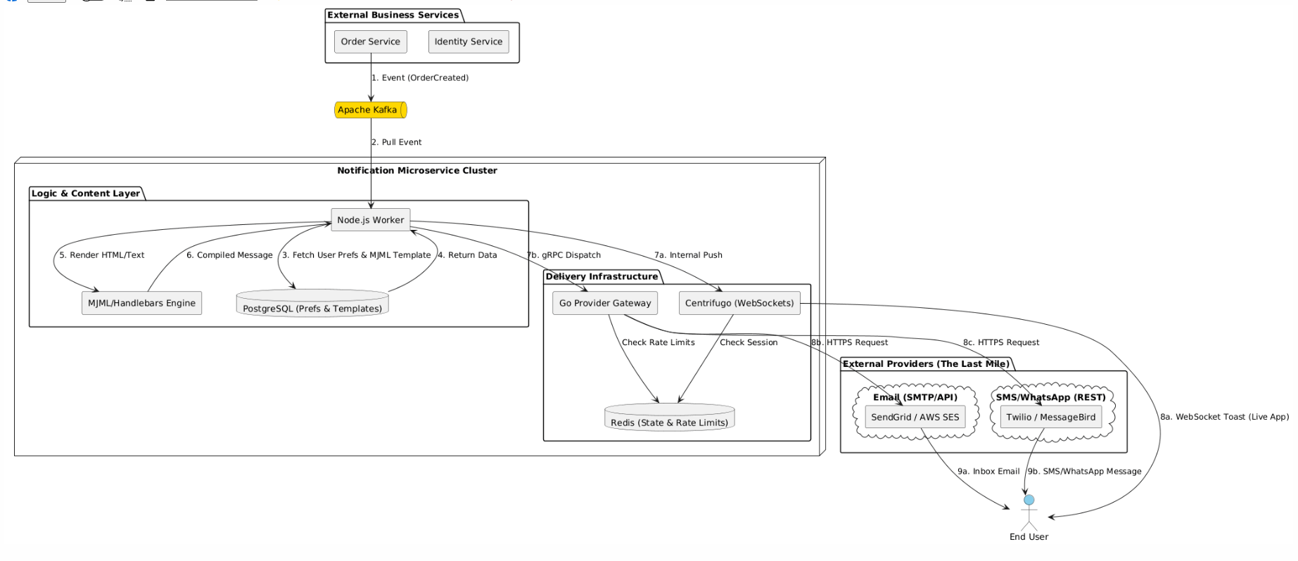
End of Document

